|  |
| --- |
| **Les Choristes – Mon Projet de Film name : form :** |

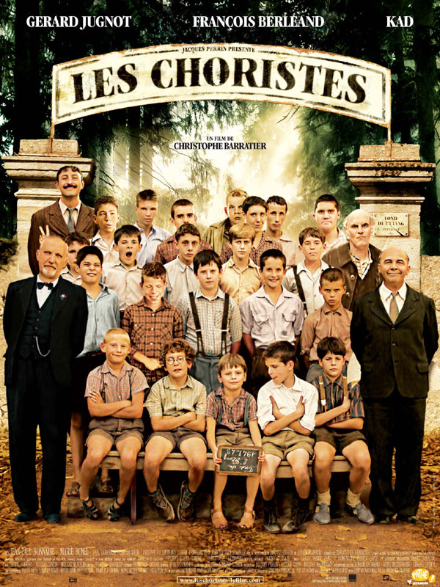

**Watching and understanding a film**

**Date**:.....................................................................................

**Réalisé par**:...........................................................................

**Acteurs principaux**...............................................................

………………………………………………………………………………………….

**Musique de**...........................................................................

***ACTIVITE 1 : qu’est ce qu’ils portent ?***

Describe what the 4 people are wearing

1

_______________________________________________________________________________________________________________

2

_______________________________________________________________________________________________________________

3

_______________________________________________________________________________________________________________

4

_______________________________________________________________________________________________________________

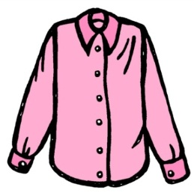***dglxasset[1]***



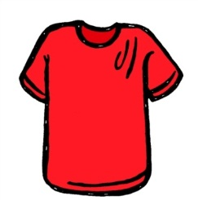***MCj02329370000[1]***

**Rappel:**

**Porter: to wear**

!!!! You need remember if the piece of clothing is feminine or masculine to add the correct adjective ending.

***ACTIVITÉ 2 : Un petit quiz! Encerclez les bonnes réponses!***

*A little quiz ! Circle the right answers !*

|  |  |  |  |
| --- | --- | --- | --- |
| **1) What does the film’s name ‘Les Choristes’ mean?** | The orphans | The choir | The singers |
| **2) What is Pierre Morhange’s job when we meet him in later life?** | A conductor | A teacher | A diplomat |
| **3) Who has just died at the start of the film?** | Clément Matthieu | The mother of Pierre Morhange | Pierre Morhange |
| **4) What is the name of the school?** | Pepinot | L’orphélinat | Fond de l’étang |
| **5) What sort of school is it?** | A school for boys with problems | A church school | A girls school |
| **6) Who is M. Rachin?** | The caretaker | The Headmaster | The Maths teacher |
| **7) Who is Père Maxence?** | The caretaker | The Headmaster | The Maths teacher |
| **8) Why does the first teacher leave?** | He was ill | He was sacked | He was attacked with scissors by one of the boys |
| **9) What is the name of the new teacher/supervisor?** | Clément Matthieu | M. Langlois | M. Rachin |
| **10) What is the name of the boy who plays the dangerous trick on Père Maxence?** | Mondain | Le Querrec | Mouton |
| **11) What era would the film be set in?** | Late 1940s – Early 1950s | 1980s | 1920s |

***ACTIVITÉ 3***: ***C’est qui? Reliez les noms et les images des personnages principaux!***

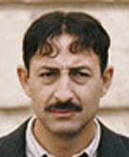*Who is it? Match up the names and the pictures of the main characters! (One person features twice…)*

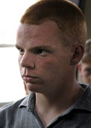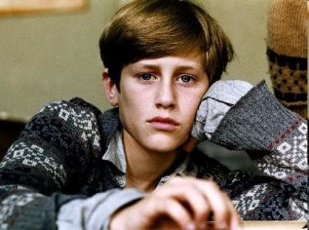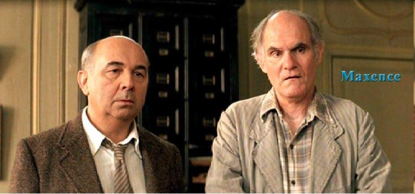

d

c

b

a

e

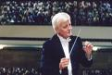[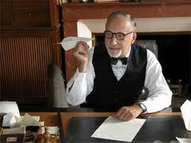](http://www.google.co.uk/imgres?q=rachin+les+choristes&um=1&hl=en&biw=1360&bih=559&tbm=isch&tbnid=Uazr-AnaGKOqLM:&imgrefurl=http://planete.qc.ca/culture/7eart/video/upavideo-452005-80005.html&docid=ZnL3JXQ7NabRyM&imgurl=http://planete.qc.ca/culture/7eart/cinema/images/rachin041009.jpg&w=300&h=225&ei=9uyTT-bQIcTe8AP0k_HNDA&zoom=1&iact=hc&vpx=693&vpy=261&dur=640&hovh=180&hovw=240&tx=121&ty=116&sig=106279394204483501750&page=1&tbnh=108&tbnw=144&start=0&ndsp=23&ved=1t:429,r:12,s:0,i:90)

g

i

f

h

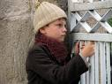

**Clément Mathieu Monsieur Rachin Le Père Maxence Mondain**

**Mme. Morhange Pépinot Pierre Morhange Monsieur Chabert**

***ACTIVITÉ 4 : Reliez les adjectifs en anglais et en français !***

*Match up the adjectives in English and in French!*

1. Sympa
2. Scary
3. Nice
4. Shy
5. Strict
6. Clever
7. Cute
8. Funny
9. Beautiful
10. Talented
11. Aggressive
12. Sad
13. sweet
14. Timide
15. Gentil
16. Effrayant
17. Agressif
18. Triste
19. Talentueux
20. beau
21. marrant
22. Sévère
23. mignon
24. intelligent

**Les personnages du film? Il est comment?**

|  |  |  |  |  |
| --- | --- | --- | --- | --- |
| **Opinion on character** | **is** | **Adjectives to describe personality** | **connectives** | **Physical description** |

|  |  |  |  |  |  |  |
| --- | --- | --- | --- | --- | --- | --- |
| -Je pense que  - Je crois que  - A mon avis  - D’après moi  + **NAME** | est | triste/gentil/sympa/  intéressant/effrayant/  talentueux/marrant/  beau/mignon/intelligent/  agressif/sévère/ | Et  Aussi  En plus | Il est | *(height and size)*  grand/petit/de taille moyenne/gros/mince/musclé. | |
| Il a | *(eyes)*  les yeux | bleus/ verts/ gris… |
| *(hair)*  Les cheveux | Noirs/marron/  blonds/  courts/ longs  raides/bouclés/ |

***ACTIVITE 5*** : ***Ecrire des phrases sur les personnages***

Mr Mathieu / Mme Morhange/ Mr Rachin/ Pépinot / le Père Maxence

e.g. Je pense que Mondain est effrayant aussi, il est grand et mince.

🡪 I think that Mondain is scary also, he is tall and thin.

1) Je pense que Monsieur Rachin est ___________________________________________________

__________________________________________________________________________________

2) ___________________________________ Mr Mathieu_________________________________

________________________________________________________________________________



**Useful vocab:**

Je pense que – *I think that…*

Je crois que – *I believe that…*

est – *is*

et – *and*

aussi – *also*

par contre – *however*

**rappel:**

to make a negative sentence

ne + verb + pas

**Challenge:**

Add some intensifier such as:

Vraiment: really

Très : very

Un peu : a little

Assez : quite

***ACTIVITE 6****:* ***les prédictions sur le film.***

*Join up the sentences to make future tense statements. Write them out completed. Then tick those you think will come true!*

***Ext.*** *can you think of any predictions of your own?*

1. 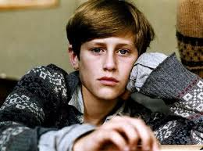M. Rachin va…
2. Pierre Morhange va…
3. Pépinot va…
4. Les enfants vont…
5. La mère de Morhange et Clément Mathieu vont…
6. Le père Maxence va…
7. Modain va…
8. Clément Mathieu va…
9. …être adopté et habiter avec Clément Mathieu – to be adopted and live with Clement Mathieu
10. 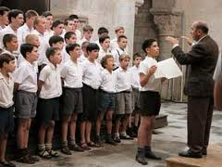…être licencié – to be fired
11. …se marier – to get married
12. …donner un concert – to give a concert
13. …devenir conducteur – become a conductor
14. …partir du college – to leave the school
15. …mettre feu au college – to set fire to the school
16. …mourir – to die

1)_______________________________________________________2)_______________________________________________________3)_______________________________________________________4)_______________________________________________________5)_______________________________________________________6)_______________________________________________________7)_______________________________________________________8)_______________________________________________________



***! Using future tense with _____ va + INFINTIVE means you are using/understanding 3 tenses!***

**Activité 7 : écrire la critique d’un film**

|  |  |
| --- | --- |
| **Opinions** | Je trouve que… Selon moi, …  À mon avis …  Il me semble que…  Je pense que |
| **Jugements** | C’est superbe/nul/raté/très réussi le film de l’année  C’est abominable/c’est véritable un navet : it’s rubblish |
| **Les genres de films** | Comique/ action/ science-fiction/romantique/historique/thriller/policier |
| **Les acteurs** | Sont supers/nuls |
| **Explications/ explanation** | parce que… / car… |
| **Les personnages/ characters** | (see what we did page 2-3) |
| **Expressions positives ☺**  **(film + personnages)** | exceptionnel(le)/ incroyable / merveilleux (-euse) / sensationnel(le) / fantastique / extraordinaire / magique /splendide / amusant(e) / drôle / divertissant(e) / très réussi(e) / agréable / intéressant(e) |
| **Expressions négatives ☹**  **(film + personnages** | déçu(e) par… disappointed by…  choquant(e) décevant(e) / nul(le) / horrible / sinistre / raté(e) / ennuyeux, ennuyeuse / peu convaincant(e) / minable /terrible |
| **Conseils/advice** | Je vous conseille de (+ inf.) I would advise you to….. |

Write in your books a small paragraph on your opinion of the film

Use the structure above to help you